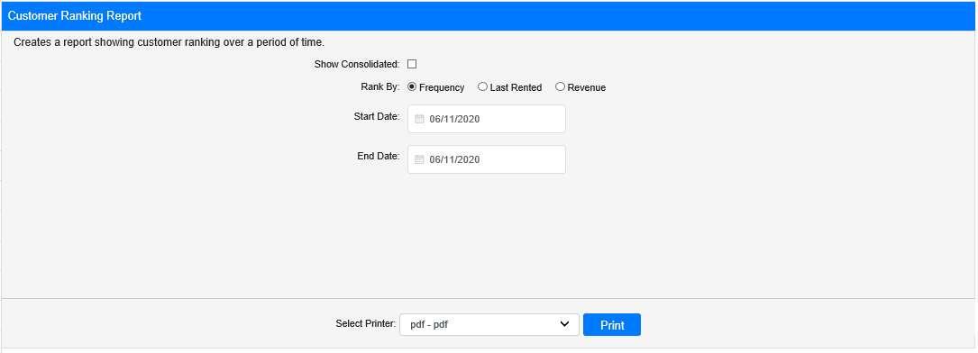

The Customer Ranking Report in Rental Reports (RR) lets you view your customers’ rankings during a specific period of time. You can rank your customers by one of three categories: by how frequently they rented from you during that time, by how recently they had an active rental with you, and by how much revenue you gained from them during that time.

Field Definitions

Show Consolidated: If you are a multi-location dealership with a Consolidated location, check this box to include the Consolidated location’s information on your report. Uncheck it to only print a report for your individual location. NOTE: If running the report in the Consolidated location, you must check this box to receive a report.

Rank By: Select how you want to rank your customers here.

Frequency: This will generate a report ranking your customers by how frequently they rented from you during the report’s time period. This is determined by how many rental contract segments with a status of Checked Out or further that they were listed on at the reporting location during this time period.

Last Rented: This will generate a report ranking your customers by which of them had the most recently active rental contract segment (where the segment was actually checked out) at the reporting location. Customers are included on the report as long as they had an active rental during the report period, and will be ranked higher the closer their actual rental end date is to the report end date. This means that rentals begun in the report time period, but still active beyond the report end date, will have the highest rankings on the report.

Revenue: This will generate a report ranking your customers by which gave you the most revenue during the report time period. The top ranked customer on this report should be the customer who spent the most money on rentals from the reporting location.

Start Date: Enter the start date for the report here.

End Date: Enter the end date for the report here.

Select Printer: Select the printer to receive the report. Use the pdf printer to preview the report.

Click “Print” to print the report.

Sample Report:

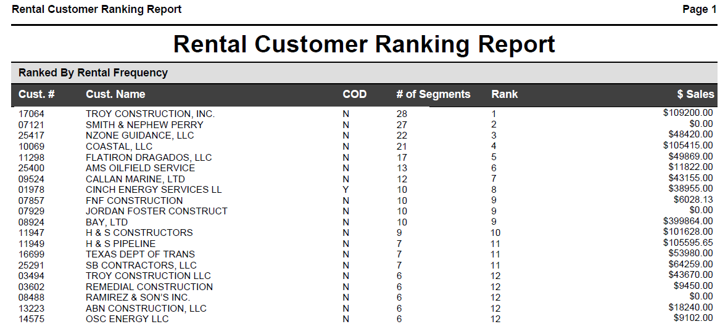

This is an example of the report with customers ranked by Frequency. As you can see in the image above, the higher the number of active, checked-out rental contract segments the customer has, the higher their ranking. For every type of ranking, the report will list all Rental customers in descending order by Rank (Rank 1 first then down), and will also display the following information:

- Customer Number
- Customer Name
- Customer’s COD Status (Y/N)
- Number of Customer’s Rental Contract Segments (only those relevant to the report within the chosen time period)
- Dollar Amount of Customer Sales (for the listed contract segments during the chosen time period)

